MED D - Test Claim - Calculating Quantity of Transdermal Patches

Definition | A Transdermal Patch is a medicated adhesive patch that is placed on the skin to deliver a specific dose of medication through the skin and into the bloodstream.
Instructions for Running a Test Claim | How many patches will you use per week?
Additional Notes | - If the prescription is written for a 90 days’ supply. There are 12 weeks in 90 days (90 ÷ 7 = 12 rounded down).  - When running a Test Claim for Estrogen Products (i.e. oral contraceptives, estrogen patches), the Days Supply must be 84 days.  - If a day supply of 90 is entered in the Quantity field, then the Test Claim will deny, displaying a Settlement Code, which indicates Day Supply Exceeds Plan Limit.
What if Test Claim Rejects | Review the rejection code to determine what caused the rejection.  Once the rejection code is identified, access the proper work instruction and job aids in theSource to help you resolve the issue.

Example
Estradiol Patch
0.05mg

Directions: Use 2 patches a week
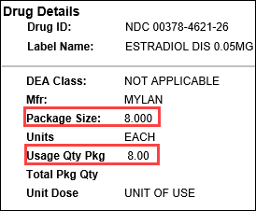 |  |  | 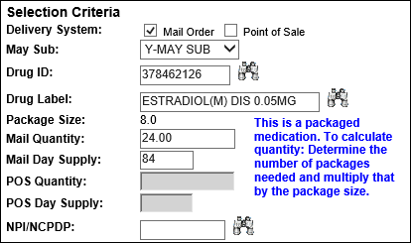
Calculation
Patches per Week | X | Weeks |  | = | Patches Needed
2 | X | 12 weeks  (84 Days) |  | = | 24  (2 x 12 = 24)
Patches Needed | ÷ | Usage Quantity Package  (from PeopleSafe) |  | = | Total Number of Boxes
24 | ÷ | 8 |  | = | 3
Total Number of Boxes | X | Package Size  (from PeopleSafe) |  | = | Test Claim Quantity
3 | X | 8 |  | = | 24

Example
Exelon Patch
4.6mg/24hr

Directions: Use 1 patch daily
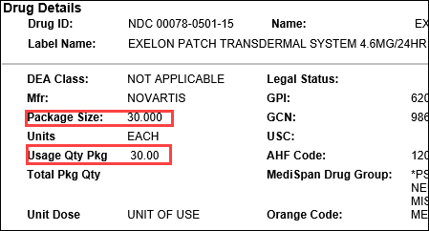 |  |  | 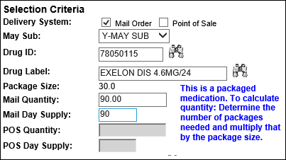
Calculation
Patches per Day | X | Days |  | = | Patches Needed
1 | X | 90 days |  | = | 90
Patches Needed | ÷ | Usage Quantity Package  (from PeopleSafe) |  | = | Total Number of Boxes
90 | ÷ | 30 |  | = | 3
Total Number of Boxes | X | Package Size  (from PeopleSafe) |  | = | Test Claim Quantity
3 | X | 30 |  | = | 90

Top of the Document

Related Documents
MED D - Test Claim Index
Calculating Quantities for Packaged Medication

Parent SOP: CALL-0049: Customer Care Internal and External Call Handling
Abbreviations / Definitions: Customer Care Abbreviations, Definitions, and Terms

Top of the Document

Not To Be Reproduced Or Disclosed to Others Without Prior Written Approval
ELECTRONIC DATA = OFFICIAL VERSION – PAPER COPY – INFORMATIONAL ONLY

